SYSTEM ANALYST REPORT FOR SCHOOL MANAGEMENT SYSTEM PROJECT

1. Introduction
A School Management System is a computerized system designed to help schools manage their daily activities efficiently. The system can manage students, teachers, classes, subjects, attendance, examinations, fees, reports, and other school information.
The role of the System Analyst is to study the existing school system, identify problems, collect user requirements, analyze the information, and provide a clear design and requirements for the development team.

2. Role of the System Analyst
The System Analyst acts as a link between the school users and the software developers. The analyst ensures that the system being developed meets the actual needs of the school.
The main responsibilities of the System Analyst include:
- Collecting system requirements.
- Analyzing the current school system.
- Identifying problems in the existing system.
- Designing the proposed system.
- Preparing system documentation.
- Creating system models and diagrams.
- Communicating with users and developers.
- Supporting system testing and implementation.

3. Analysis of the Existing System
Before developing the School Management System, the System Analyst studies how the school currently performs its activities.
The existing system may use:
- Paper records.
- Exercise books.
- Excel spreadsheets.
- Manual attendance registers.
- Physical examination records.
- Manual fee records.
The analyst observes how information is collected, stored, processed, and retrieved.

Problems Identified
The analysis may identify the following problems:
- Loss of student records.
- Difficulty in searching for information.
- Duplication of records.
- Slow preparation of reports.
- Errors when calculating examination results.
- Difficulty in tracking student attendance.
- Poor management of fee records.
- Large amounts of paperwork.
- Unauthorized access to confidential information.
- Difficulty in sharing information between departments.

4. Requirements Gathering
The System Analyst collects requirements from different users of the school.

Main stakeholders include:
- Principal/Head Teacher
- Teachers
- School administrators
- Students
- Parents/Guardians
- Accountant
- System Administrator
The analyst can collect information through:
- Interviews
- Questionnaires
- Observation
- Document review
- Meetings

5. Functional Requirements
The School Management System should provide the following functional requirements:

5.1 Dashboard
The dashboard provides an overview of the school system. It displays important information such as the total number of students, teachers, classes, subjects, attendance records, and examination information.

5.2 Student Management
The Student module allows the administrator to:
- Add new students.
- View student information.
- Update student records.
- Search for students.
- Manage student details.

5.3 Teacher Management
The Teacher module allows the administrator to:
- Add new teachers.
- View teacher information.
- Update teacher records.
- Manage teacher details.
- Assign teachers to classes or subjects.

5.4 Class Management
The Class module allows the administrator to:
- Create classes.
- View class information.
- Update class information.
- Assign students to classes.
- Assign teachers to classes.

5.5 Subject Management
The Subject module allows the administrator to:
- Add new subjects.
- View subjects.
- Update subject information.
- Assign subjects to classes.
- Assign teachers to subjects.

5.6 Attendance Management
The Attendance module allows teachers to:
- Record student attendance.
- View attendance records.
- Update attendance information.
- Monitor student attendance.
- Generate attendance information for reporting.

5.7 Examination Management
The Exams module allows teachers and authorized users to:
- Enter examination marks.
- Update examination marks.
- View students' marks.
- Calculate examination results.
- Monitor students' academic performance.

5.8 Reports
The Reports module allows authorized users to generate and view different school reports, including:
- Student reports.
- Teacher reports.
- Class reports.
- Attendance reports.
- Examination reports.

5.9 Settings
The Settings module allows the administrator to manage system configurations and user-related settings. It may include:
- User account management.
- Password management.
- System configuration.
- Security settings.

5.10 Logout
The Logout function allows users to securely exit the School Management System. It ends the current user session and helps prevent unauthorized access to the system.

Summary of Functional Requirements
No. | Module | Main Function
1 | Dashboard | Displays a summary of school information
2 | Students | Manages student information
3 | Teachers | Manages teacher information
4 | Classes | Manages classes and assignments
5 | Subjects | Manages subjects
6 | Attendance | Records and manages student attendance
7 | Exams | Manages examination marks and results
8 | Reports | Generates school reports
9 | Settings | Manages system and user settings
10 | Logout | Securely ends the user's session

6. Non-Functional Requirements
The System Analyst should also identify non-functional requirements.

Security
Only authorized users should access the system according to their roles.

Performance
The system should respond quickly when users search, enter, or retrieve information.

Reliability
The system should operate correctly and minimize data loss.

Usability
The system should have a simple and user-friendly interface.

Maintainability
The system should be easy to maintain and update.

Backup
Important school data should be backed up regularly to prevent data loss.

7. System Users and Their Responsibilities
User | Main Responsibilities
Administrator | Manage users, students, teachers, classes, and subjects
Teacher | Manage attendance, marks, and student academic information
Accountant | Manage fees and payment records
Principal | View school information and reports
Student | View personal information, attendance, and results
Parent | View student academic and attendance information
System Administrator | Manage system security and technical settings

8. System Analysis Diagrams
The System Analyst prepares different diagrams to explain how the system will work.
These may include:

Use Case Diagram
Shows the interaction between users and the School Management System.

Data Flow Diagram (DFD)
Shows how data moves between users, processes, and data stores.

Entity Relationship Diagram (ERD)
Shows the relationships between database entities such as Student, Teacher, Class, Subject, Attendance, Examination, and Fees.

Activity Diagram
Shows the steps involved in performing a particular activity.

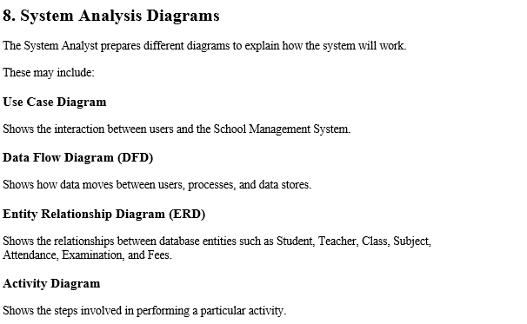

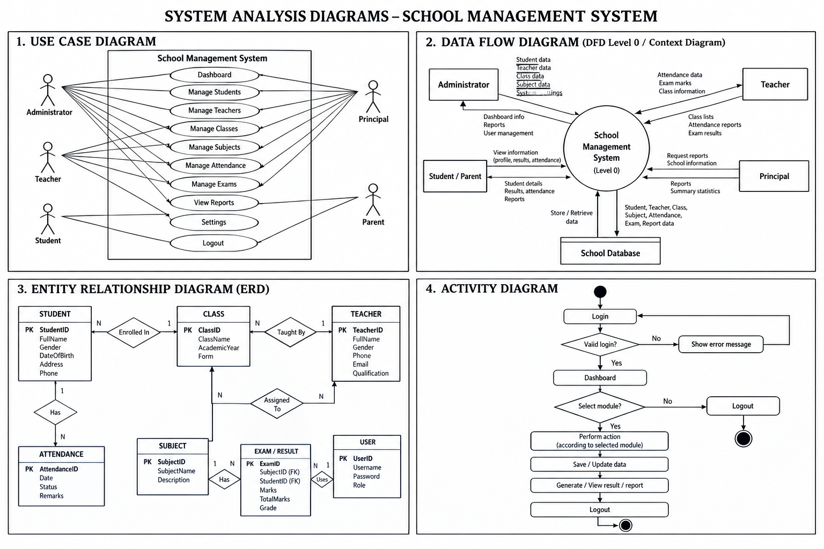

9. Proposed System
The proposed School Management System will replace or reduce manual processes by providing a centralized computerized system.
For example, instead of keeping student attendance in a paper register, a teacher can log into the system, select a class, record attendance, and save the information in the database.
The administrator can then generate attendance reports whenever required.

10. Benefits of the Proposed System
The proposed system will provide several benefits:
- Reduces paperwork.
- Saves time.
- Improves data accuracy.
- Makes information easy to search.
- Improves data security.
- Makes report generation easier.
- Reduces duplication of records.
- Improves communication between school departments.
- Provides centralized data storage.
- Makes school management more efficient.

11. System Analyst Deliverables
At the end of the analysis stage, the System Analyst should provide:
- Requirements specification.
- Functional requirements.
- Non-functional requirements.
- Use Case Diagram.
- Data Flow Diagram.
- Entity Relationship Diagram.
- Activity Diagrams.
- System process descriptions.
- Database requirements.
- System analysis report.

12. Conclusion
The System Analyst plays an important role in the development of the School Management System. The analyst studies the existing school operations, identifies problems, collects requirements from stakeholders, analyzes the requirements, and prepares system models and documentation.
The main purpose of the analyst's work is to ensure that the final School Management System solves the problems of the school and meets the needs of its users. A good system analysis helps developers build a system that is secure, reliable, efficient, and easy to use.

